# 

# **Web Development Training**

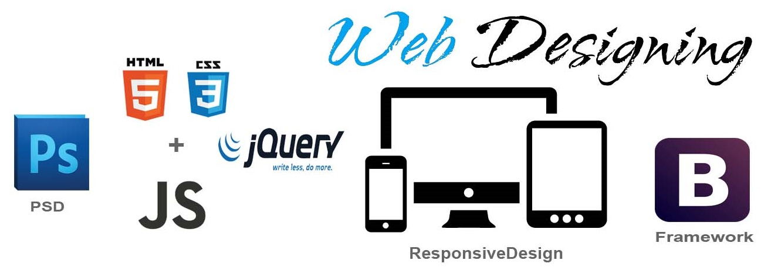

Based upon your requirement we are pleased to send you the course curriculum for Web Development Training Given below is the brief description for the course you are looking for:

## Web Development Training Details:

|  |  |
| --- | --- |
| Course Name | Web Development |
| Course Duration | 6 weeks |
| Practical Sessions | Yes |
| Experience | 6 years Industrial Experience. |
| Time | Saturday: 5:00 PM to 8:00 PM |
| Sunday: 5:00 PM to 8:00 PM |

**1- Topics in HTML5**

* HTML5 Intro
* HTML Doctype
* HTML Hyperlink
* HTML Table
* HTML Attributes
* HTML Tags
* HTML5 New Elements
* HTML5 New Attributes
* HTML5 Semantic Attributes
* HTML5 Audio Tag
* Html5 Video tag
* HTML5 New Form Elements
* HTML5 Local & Session Storage
* HTML Block and Inline Elements
* HTML5 Compatibility: HTML5shiv.js (For tags support on IE8 and below)

**2- Topics in CSS3**

* CSS3 Intro
* CSS3 Selectors
* CSS3 Properties
* CSS3 Vendor Specific Prefixes
* CSS3 Colors
* CSS3 Backgrounds
* CSS3 Gradients
* CSS3 Transformation
* CSS3 Transitions
* CSS3 Animations
* CSS3 Filter Properties
* CSS Box Model
* CSS Outline
* CSS Float
* CSS Clear
* CSS Lists
* CSS Pseudo Selectors
* CSS Backgrounds
* CSS Display
* CSS Positions
* CSS Drop Down Menu
* CSS Margins
* CSS Shadows
* CSS Box Sizing
* Media Queries
* CSS Position
* CSS Opacity
* CSS Attr Selectors
* CSS padding

**3- Topics in JavaScript**

* JavaScript Intro
* JavaScript Variables
* JavaScript Comments
* JavaScript Datatypes
* JavaScript Strings
* JavaScript Operators
* JavaScript Strict Mode
* JavaScript Scope
* JavaScript Booleans
* JavaScript Dates
* JavaScript Date Formats
* JavaScript Date Get Methods
* JavaScript Date Set methods
* JavaScript Comparisons
* JavaScript Break
* JavaScript Hoisting
* JavaScript Numbers
* JavaScript DOM
* DOM Selectors
* JavaScript Events
* Event Listeners
* Event Propagation
* JavaScript Functions
* JavaScript Function Closures
* JavaScript Function Call
* JavaScript Function Apply
* JavaScript Conditions
* JavaScript Loops
* JavaScript Arrays
* JavaScript Object Method
* JavaScript Object Prototype
* JavaScript Object Constructors
* JavaScript JSON Object
* JavaScript AJAX
* JavaScript Window Objects
* JavaScript Screen Objects
* JavaScript History Objects
* JavaScript Location Objects
* JavaScript Navigator Objects
* JavaScript Date Objects
* JavaScript Math
* JavaScript Timing Functions
* JavaScript Regex Object
* JavaScript DOM Navigation
* JavaScript Array Sort
* JavaScript Array Method
* JavaScript Array Sort
* JavaScript Objects

**4- Topics in jQuery**

* jQuery Introduction
* jQuery Syntax
* jQuery Selectors
* jQuery Events
* jQuery Call-back
* jQuery Chaining
* jQuery CSS Classes
* jQuery Traversing
* jQuery Siblings
* jQuery Animate
* jQuery Stop ()
* jQuery Get
* jQuery Set
* jQuery Add
* jQuery Dimensions

**5- Topic in Angular6**

* Angular6 Introduction
* Angular6 Environment Setup
* Angular6 Components
* Angular6 Module
* Angular6 Data Binding
* Angular6 Event Binding
* Angular6 Directives
* Angular6 Pipes
* Angular6 Routing
* Angular6 Services
* Angular6 Http Services
* Angular6 Forms
* Angular6 @Input/@Output
* Angular6 Observer and Observable
* Angular6 RxJS
* Angular6 Lifecycle Hooks
* Angular @viewChild
* Angular6 Subject/BehaviorSubject
* Angular6 Lazy loading
* Angular6 Routing Guard
* Angular6 Compodoc Documentation
* Angular6 Unit Testing

**6- Topics in SASS**

* What is Sass
* Sass Vs Less
* Sass Installation
* How to use sass
* Integrate Sass with Project

**7- Topics in LESS**

* What is Less
* Sass Vs Less
* Less Installation
* How to use Less
* Integrate Less with Project
* LESS Variables
* LESS Mixins
* LESS Nesting
* LESS Functions

**8- Topics in BootStrap3**

* What is BootStrap3?
* BS Grid Basic
* BS Tables
* BS Jumbotron
* BS Collapse
* BS Tabs/Pills
* BS Navbar
* BS Tooltip
* BS Grid Small
* BS Grid Medium
* BS Grid Large
* BS Grid Examples
* BS class
* BS Buttons
* BS Glyph icons
* BS Badges/Labels